<https://www.tutorialspoint.com/gerrit/gerrit_update_master.htm>

https://www.tutorialspoint.com/gerrit/gerrit_add_ssh_key_to_gerrit_account.htm

https://www.tutorialspoint.com/gerrit/gerrit_add_ssh_key_to_gerrit_account.htm

<https://www.tutorialspoint.com/gerrit/gerrit_update_master.htm>

https://shareprogramming.net/tong-hop-35-lenh-git-co-ban/

Git –version

<http://gerrithub.io/>

$ git push origin HEAD:refs/for/master

HEA

sudo apt-get install git : cai git

git config --global user.email "your_email@mail.com"

git config --global user.name "your_name"

Generating New SSH Key

You can generate a new SSH key for authentication using the following command in Git Bash −

$ ssh-keygen -t rsa -C "your_email@mail.com"

ssh-keygen

exec ssh-agent bash

web1:

<https://gerrit.wikimedia.org/r/login/%23%2Fq%2Fstatus%3Aopen>

[status:open · Gerrit Code Review (wikimedia.org)](https://gerrit.wikimedia.org/r/q/status:open)

username: sunset / Ch…@#

chieubkhn@gmail.com

[Gerrit - Add SSH Key to your Gerrit Account (tutorialspoint.com)](https://www.tutorialspoint.com/gerrit/gerrit_add_ssh_key_to_gerrit_account.htm)

<https://gerrit.wikimedia.org/>

username: sunset / Ch…@#

chieubkhn@gmail.com

web2:

<https://review.gerrithub.io/admin/repos>

[chieubkhn@gmail.com](mailto:chieubkhn@gmail.com) // dung tk github

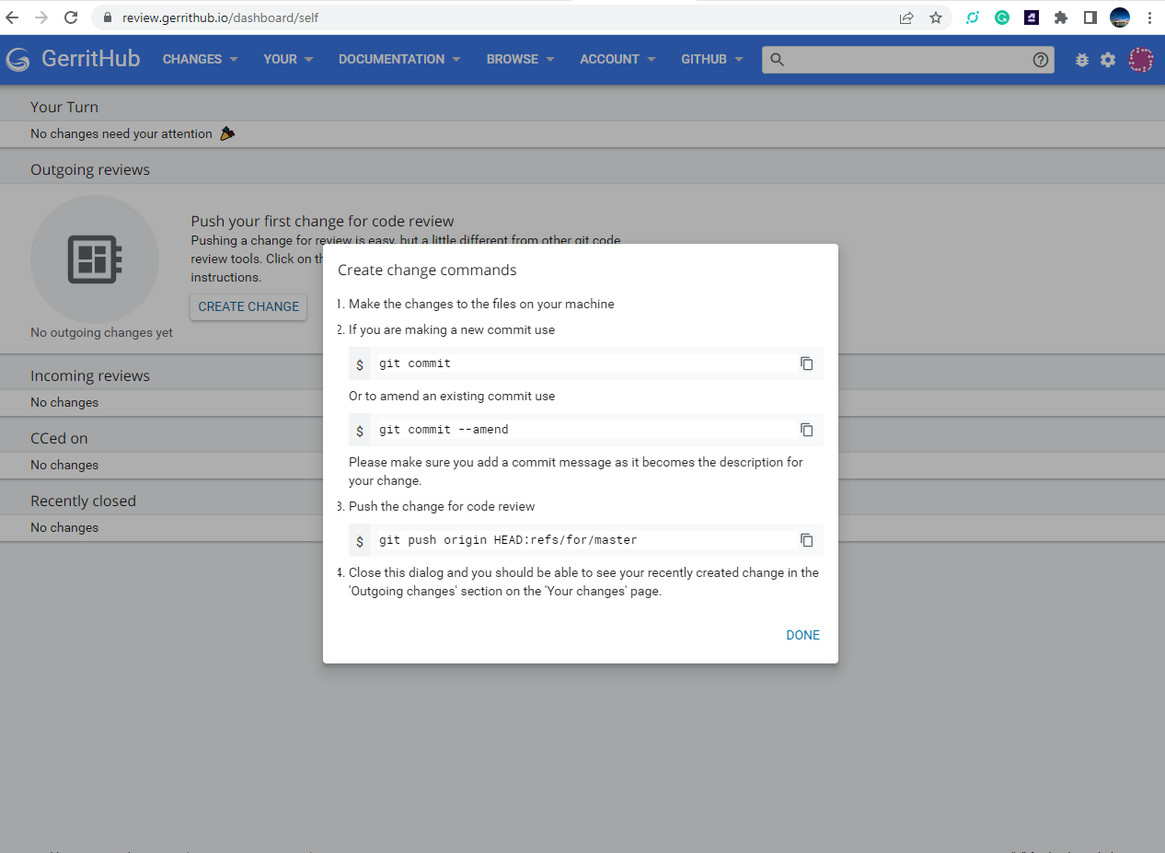

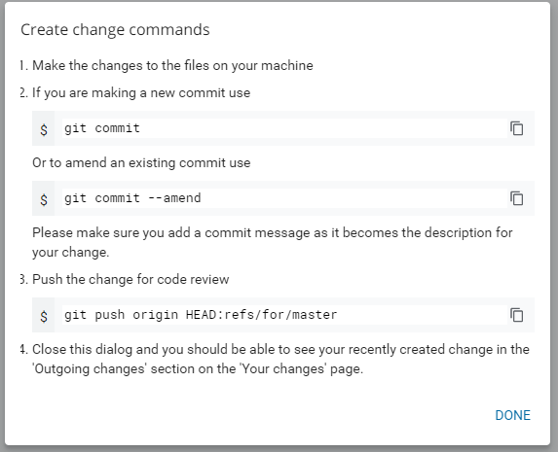

Create change commands

1. Make the changes to the files on your machine
2. If you are making a new commit use

 git commit

Or to amend an existing commit use

 git commit --amend

Please make sure you add a commit message as it becomes the description for your change.

1. Push the change for code review

 git push origin HEAD:refs/for/master

1. Close this dialog and you should be able to see your recently created change in the 'Outgoing changes' section on the 'Your changes' page.

<https://review.gerrithub.io/admin/repos/0x707/gerrit_train,general>

[**https://gerrit.wikimedia.org/r/admin/repos/3d2png,general**](https://gerrit.wikimedia.org/r/admin/repos/3d2png,general)

**git reset --hard HEAD^ : xoa commit local tren cung**

git reset --hard HEAD~n : xoa n commit tren cung

# [**git push gerrit HEAD:refs/for/master**](https://stackoverflow.com/questions/10461214/why-is-git-push-gerrit-headrefs-for-master-used-instead-of-git-push-origin-mast)

# [**git push gerrit HEAD:refs/for/master**](https://stackoverflow.com/questions/10461214/why-is-git-push-gerrit-headrefs-for-master-used-instead-of-git-push-origin-mast)

# [**git push HEAD:refs/for/master**](https://stackoverflow.com/questions/10461214/why-is-git-push-gerrit-headrefs-for-master-used-instead-of-git-push-origin-mast)

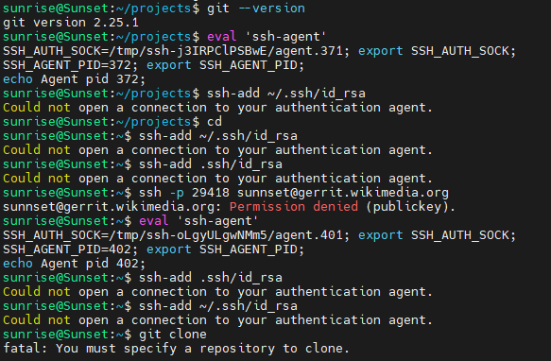

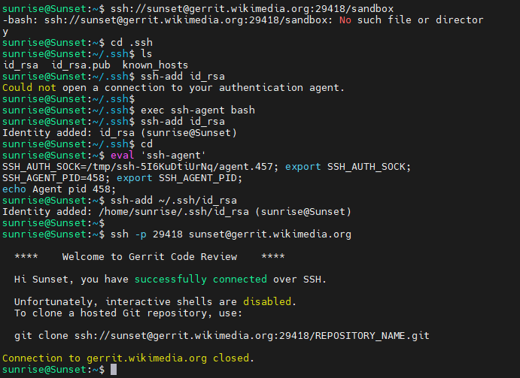

**ssh -p 29418** [**sunset@gerrit.wikimedia.org**](mailto:sunset@gerrit.wikimedia.org)

**ssh -p 29418** [**sunset@gerrit.wikimedia.org**](mailto:sunset@gerrit.wikimedia.org)

**ssh -p 29418** [**sunset@gerrit.wikimedia.org**](mailto:sunset@gerrit.wikimedia.org)

**git clone ssh://sunset@gerrit.wikimedia.org:29418/REPOSITORY_NAME.git**

**git clone ssh://sunset@gerrit.wikimedia.org:29418/REPOSITORY_NAME.git**

**git clone ssh://sunset@gerrit.wikimedia.org:29418/REPOSITORY_NAME.git**

git clone ssh://sunset@gerrit.wikimedia.org:29418/sandbox

GNU nano:

Luu file ctr + o => enter

Thoat ctr + x => endter neu can

git commit --amend --no-edit

Ctr +g : show all command